SOCIAL ROBOTICS

**EMPATHIC ROBOT: CAREGIVER FOR SENIORS**

TECHNICAL REPORT

linea orizzontale

# 

# 

# 

# 

# 

# 

# 

# 

# 

# 

# 

# 

# 

# 

# 

# 

# 

# 

# *Claudio Pace Claudia Sgarra Giuseppe Gallone*

# INTRODUCTION

The aging of the population is a reality common to the whole Western world, while the time available and human resources are limited. According to many experts, new robotic technologies could help meet the care needs of the elderly, both those who can live at home and those who live in hospitals and retirement homes. Welfare robotics could foster their autonomy and provide support to operators in the sector.

Welfare robots are part of the so-called social robots, autonomous or semi-autonomous machines capable of interacting and communicating with humans or other physical agents following social behaviors and rules related to their specific role and the context in which they operate. They are designed to provide help and social interaction to people in everyday life, as well as cognitive support, training and support for practitioners.

A social robot should not only provide aid to human activities, but should also try to establish an empathic social relationship with the user. It is therefore very important to equip the robot with the ability to recognize the user's affective state and try to immerse itself in his shoes.

Our idea is to implement empathy in a robot’s mind in a specific area: seniors’ assistant. To do this, we first designed some scenarios in which a robot and a senior interact, then we asked some caregivers to answer a survey, in which we asked them to explain their behavior in those scenarios. After answers’ analysis, we implemented a computational model on Hugin software. At the end, we tested our model into a graphical interface simulating a dialogue between a robot and a senior man/woman.

### PRELIMINARY PHASE

**PERSONAS**

We thought about two figures, a first one resident in an RSA and another one who lives at home assisted by a caregiver, both suffering from different pathologies.

**Giuseppe** is a 70-years senior man. His wife is recently deceased and his children live in another city. Suffering from arthrosis and needing to be assisted, he decided to live in an RSA. Giuseppe is very pleasant and sociable and he socialized with all the guests of the RSA. He calls everyone by name just like in a family and is particularly attached to his assistant.

**Maria** is a 75-year-old widow and lives alone at home but needs assistance because her three daughters work and are always busy looking after their too young children. Maria is an introverted, stubborn and autonomous person; she often gets angry when an assistant helps her in daily household chores. She suffers from heart disease, so it's very important that she always stays quiet. Her health is very unstable, there are days when she is in health and others more critical, both physically and psychologically.

**Giuseppe’s SCENARIOS**

1. It is Saturday night and usually Giuseppe plays cards with his friends in the common room: the caregiver goes there to give him his evening pills but he is not there. He goes into his room and finds Giuseppe sitting on the bed staring blankly. From his face it seems very sad and he keeps repeating phrases like "I am left alone", "I feel alone".
2. Giuseppe usually sleeps at 10pm already, but this evening he just can't: it's midnight and he's still awake. Giuseppe rings the bell near the bed for assistance. The caregiver goes to his room and asks what is going on. Giuseppe replies: "I can't sleep tonight, yet I'm tired!"
3. At the morning check-up some of Giuseppe's vital signs and blood glucose level were irregular, so the doctor recommended that he avoid eating certain foods. During lunch, he sees Giuseppe eating something he shouldn't be because it can be harmful to his health.
4. It's time for physiotherapy and he's gathering everyone in the gym. Giuseppe complains of pain/discomfort in his legs, but she knows perfectly well that she is faking it, because it is not the first time she has done it. In fact, she doesn't want to go to rehabilitation therapy because she thinks she is boring and she would rather do something else.

**Maria’s SCENARIOS**

1. The caregiver is alone with Maria, they are preparing to go to the doctor for an important visit. For this reason Maria is anxious, she is trembling and afraid. She hears her uttering phrases such as "let's hope it goes well", "I'm afraid of what the doctor will say".
2. Maria's doctor has prescribed some medicines that she must necessarily take. Due to her pathology she cannot get upset, but despite this, she often gets nervous. Today Maria refuses to take the medicines; her face shows that she is very angry and she says she is tired of always taking medicines. She utters phrases such as: "enough with these medicines", "these medicines are useless", "they are money spent in vain", "I don't want to take them anymore".
3. Today is a very cold day. She sees Maria snorting around the house, she would like to go out for a walk and she complains of feeling caged within the walls of the house. The caregiver explains to Maria that we can't go out today because it's too cold and this can aggravate her health, but she insists on going out and gets upset.
4. The caregiver sees Mary very happy and asks her why. Tonight her grandchildren will come to her house to visit her and that's why she can't wait for evening to come. She is preparing the favorite dishes for her grandchildren, in fact the caregiver notices that she is more sunny and cheerful than usual.

**QUESTIONNAIRE**

In this preliminary phase, we have submitted a questionnaire to some carers and healthcare assistants. It was composed of two parts: in the first part we asked some questions about the age, their career and some personality traits, then we asked an opinion about the requirements that a healthcare assistant should have; in the second part, we presented the scenarios and for each of them we asked the following questions.

* After reading this scenario, what do you think is Giuseppe/Maria’s state of mind? Choose one or more options or specify something else.
* If you were Giuseppe/Maria’s assistant, what would your mood be?
* What behavior would you take to assist Giuseppe/Maria?
* If you were to summarize the kind of assistance you provided Giuseppe/Maria, which of the following words would you use?

**ANSWERS**

Most caregivers who answered the questionnaire fall into the age group between 31 and 45 years and have been dealing with elderly care for about 3-10 years. Most of them are extroverts and empathic people. In fact, they think that being empathic is the most important requirement for the senior care assistant. Other requirements they think are very important are patience andattention, instead a bit less important are severity, extraversion, thoughtfulness and sociability.

For the first scenario of Giuseppe, most of them think that Giuseppe is feeling alone and the assistent would feel sadness and they would encourage him talking and make him focus on the positive aspects.

For the second scenario, they think that Giuseppe feels alone and nervous and they would be neutral. In this case most of them would talk to him and help him sleep in some way, summarizing this kind of assistant with the word “calm down”.

In the third scenario, the assistants were confused about Giuseppe’s mood. Each of them gives different answers: somebody thinks that it was confused or distracted, others thinks that he was suffering, still others think that he did not understand what he risks. Also for the assistant's mood, there are different answers including sadness, frustration, anxiety or be neutral. But everyone agrees on the behavior to adopt: correct him and explain again what the doctor told him, in a word “encourage him” .

In the last Giuseppe’s scenario, our assistants think that Giuseppe is suffering or he is nervous or still he is lazy. Their mood would be neutral and they all would encourage him to do the physiotherapy.

Regarding Maria, in the first scenario, they think she is nervous and afraid. Some of them would be calm and neutral, others would be anxious, but they all would calm her down and encourage her to deal with the situation.

In the second scenario, the assistants think that Maria is nervous and they would be anxious too. But they have different opinions about the behavior to adopt because somebody would ask the help of a nurse, somebody would try to convince her by explaining the reason for taking medicines and others would talk to her to understand her emotions. So the most common words to summarize the kind of assistance are “calm down” and “encourage her”.

If our caregivers were Maria’s assistants in the third scenario, they would think that she is nervous but they would be neutral. In this case, there is an interesting difference about the behavior to adopt: most of them would convince her not to go out distracting her, a minority would make her dress in appropriate clothing and go out for a walk with her. In any case, the most appropriate word to describe this kind of assistance is “distract her”.

In the fourth Maria’s scenario, they all perceive that she feels happy and they would be happy too. Also for the behavior to adopt they all agree to help her with the preparations.

Link to the questionnaire: *https://forms.gle/RP7BYLVzwFHGApxr7*

**EMPATHY**

We started from the definition of *empathy*:

***Empathy is the ability to "put yourself in the other person's shoes" by perceiving, in this way, emotions and thoughts.***

It is a social skill of fundamental importance and represents one of the basic tools for effective and rewarding interpersonal communication. In interpersonal relationships, empathy is one of the main doors of access to states of mind and in general to the world of the other. Thanks to it, you can not only grasp the sense of what the interlocutor asserts, but also grasp the innermost psycho-emotional meaning. This allows us to expand the value of the message, capturing elements that often go beyond the semantic content of the sentence, explaining its metacommunication, that is, that truly significant part of the message, expressed by the language of the body, which can be decoded precisely thanks to the empathic listening.

[*https://www.stateofmind.it/empatia/*](https://www.stateofmind.it/empatia/)

To simulate the cognitive aspect of empathy in a robot, this had to be endowed with the capability of recognizing and understanding the affective state of the user. Due to the conversational nature of the interaction between the user and the robot, the user’s affective state is recognized by analyzing communicative signs extracted from speech and facial expressions.

But the affective state alone is not enough to detect the user's mood that is also influenced by the desirability of an event that depends on event, the context and on the observed action.

If the robot is empathic, it should have the same mood as the user. But the own emotion of the robot is influenced also by the desirability of the event for the robot and the evaluation of the evidence of what the user is feeling (if he is lying or not).

Based on the emotion of the robot, he adopts a behavior to achieve a goal.

We represent this model on a Bayesian Network.

# 

# 

# 

# 

# HUGIN: The Bayesian Network

*“Bayesian network combine sophisticated algorithms with modern computing power to uncover new insight and model complex risk and decision problems where sound analysis is needed, but where uncertainty exists.”*

*hugin.com*

Our interpretation about empathy’s concept from the point of view of a robot has been poured out into a Bayesian network with **Hugin** software.

The purpose of this computational model is to understand how a “caregiver” robot behaves with a senior man/woman in specific situations (for example, scenarios mentioned above). We started by framing the situation’s concept: firstly, the robot acquires data from the person in front of it and from the surrounding environment as if it were taking a photograph of that exact point in time. In this way you acquire data on:

1. **observed emotion** - main emotions
2. **text:** words spoken by the user (polarity: positive, neutral, negative)
3. **face** (main emotions)
4. **voice** (main emotions)
5. **user’s desirability** about specific event - (polarity: positive, neutral, negative)
6. **observed action** (polarity: positive, neutral, negative)
7. **event**  (polarity: positive, neutral, negative)
8. **context**  (polarity: positive, neutral, negative)
9. **user’s mood** - main emotions

that can be integrate with other informations like these

1. **robot’s desirability** about specific event (polarity: positive, neutral, negative)
2. **evidence’s evaluation**: a check on the truthfulness of the words spoken by the user
3. **user’s mood in robot opinion** - main emotions
4. **robot’s mood** - main emotion
5. **empathy** - empathic robot / non-empathic robot
6. **relationship** between robot and user
7. **goals** or empathic actions (es. consulare, encourage, scold up, cheer up etc.)

Each of these elements concurs to the definition of a single node with its attributes in the Hugin’s Bayesian network.

# 

# 

# 

# 

# 

# 

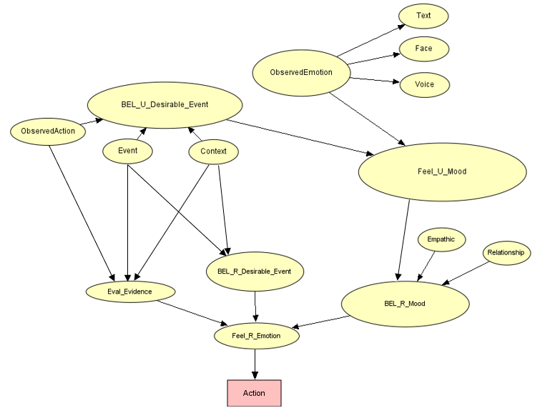

# 

# 

# 

# 

# 

# 

# Model.oobn

N.B. Observing this image, you will notice this is just one file. Two different OOBN files have been used to reproduce this network due to the Hugin software license. The free version of the software (used in this project) allows us to create a predefined number of nodes with a limited number of attributes; in this way, we had to split our network in two different files. This diagram has been produced only for a clearer and more correct explanation of the entire network.

**WORKING EXAMPLE**

In this example we set the model with the following evidences:

* Face → fear
* Text → negative
* Event → positive
* ObservedAction → negative
* BEL_R_Desirable_Event → positive
* Relationship → positive
* Empathic → true

# 

# 

# 

# “Goals” node by Hugin

# 

The image demonstrates that, given these parameters, the robot’s objective will be to encourage the user with a probability of ~77%.

# 

# PyBBN

For simulating our computational model in Python, we used PyBBN library.

It’s a Python implementation of probabilistic and causal inference in Bayesian Belief Networks (BBN) using exact inference algorithms. BBN is a Probabilistic Graphical Model (PGM) that represents conditional dependencies between random variables through a Directed Acyclic Graph (DAG). The main objective of these networks is trying to understand the structure of causality relations. At the base of this concept, the *conditional probability:* the probability of a random variable when some other random variable is given.

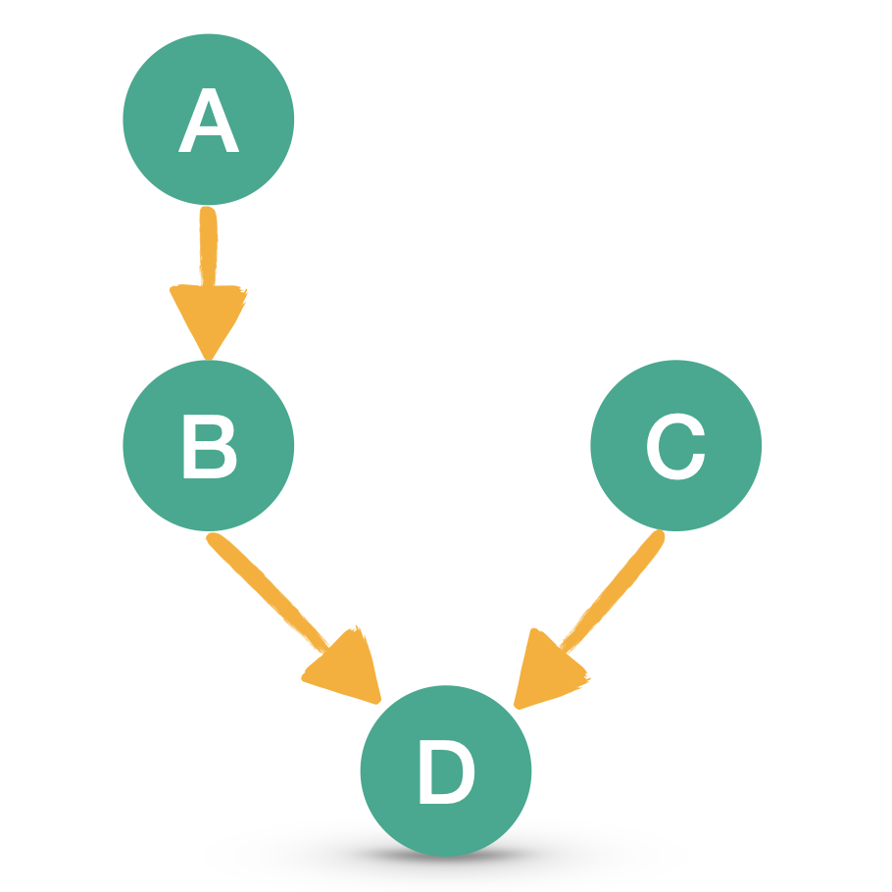

# 

# 

# 

# 

# BBN executive flow

# 

# DIALOGUES

For testing results of the computational model and imagining robot’s reaction into a possible daily life situation of a senior, we have implemented two dialogues examples for all of the first two scenarios of each personas: in the first case, robot will have an empathic behavior; in the second one, instead, robot will take a more detached attitude and perform exclusively its task.

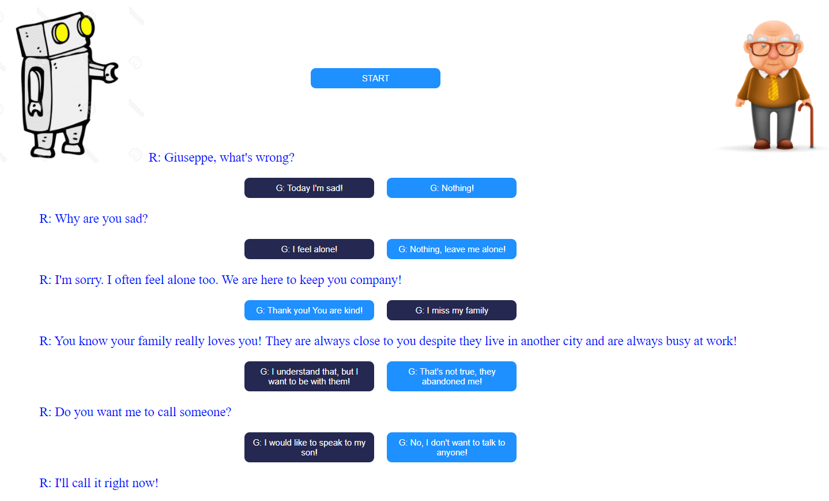

This is the example dialogue for Giuseppe’s first scenario from the HTML page. Phrase selection keys allow you to select the answer that Giuseppe could give to the robot's phrase or question.

# 

# DJANGO: Python Web Framework

*“Django is a high-level Python web framework that encourages rapid development and clean, pragmatic design. Built by experienced developers, it takes care of much of the hassle of web development, so you can focus on writing your app without needing to reinvent the wheel. It’s free and open source.”*

*djangoproject.com*

For holding all the elements of this project, we have implemented a web framework composed by the following screens:

* personas’ selection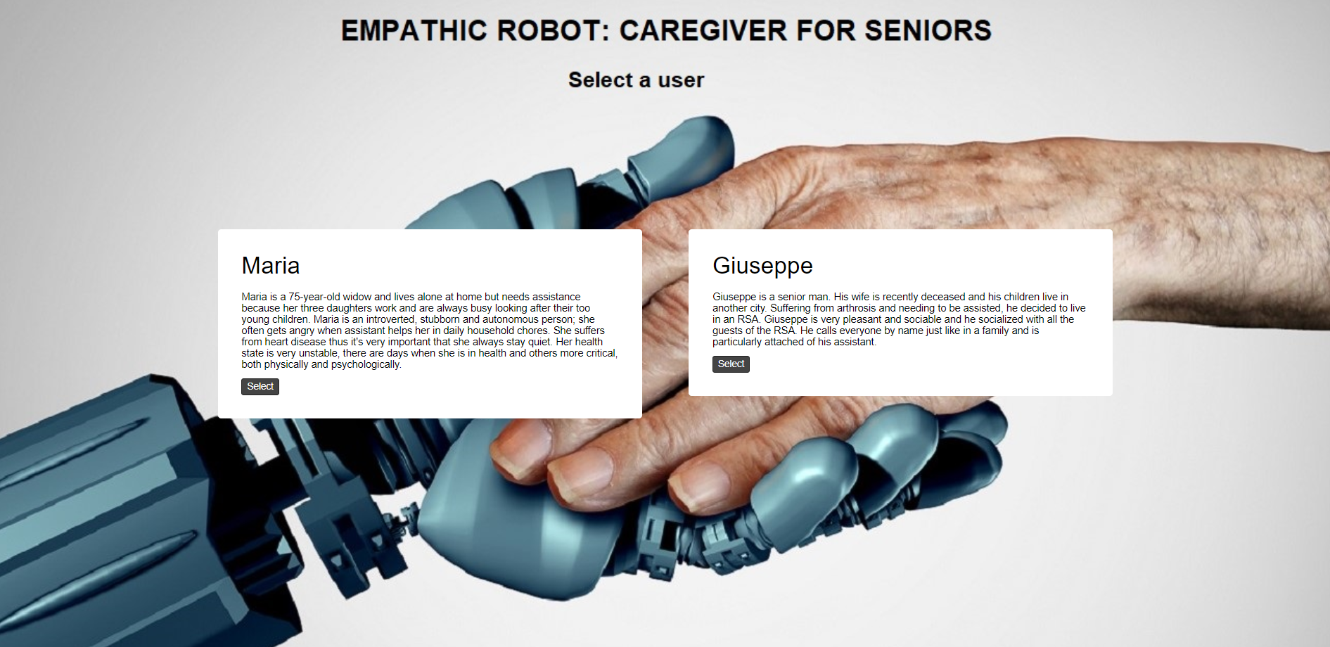
* scenario’s description for the selected personas and evidences setting menu

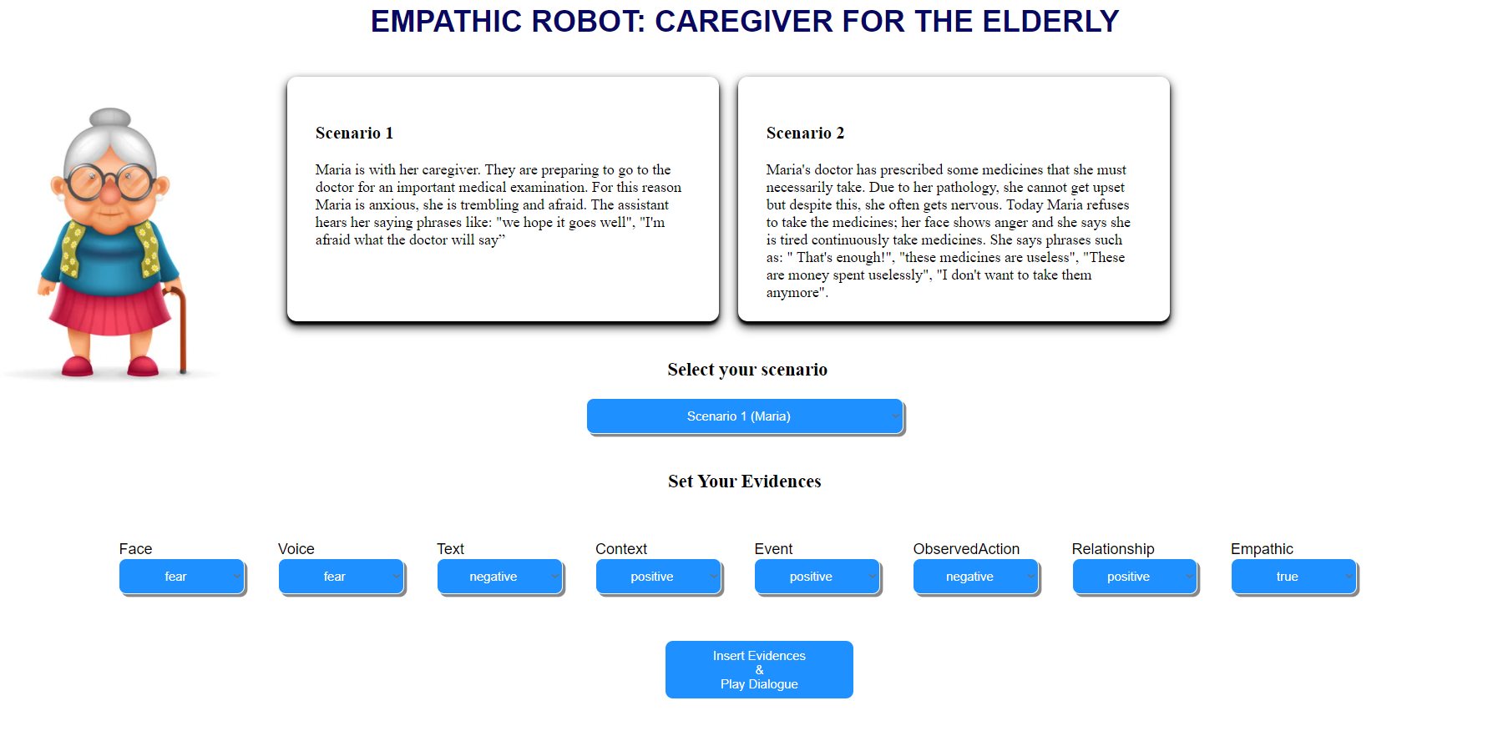

* dialogue’s page

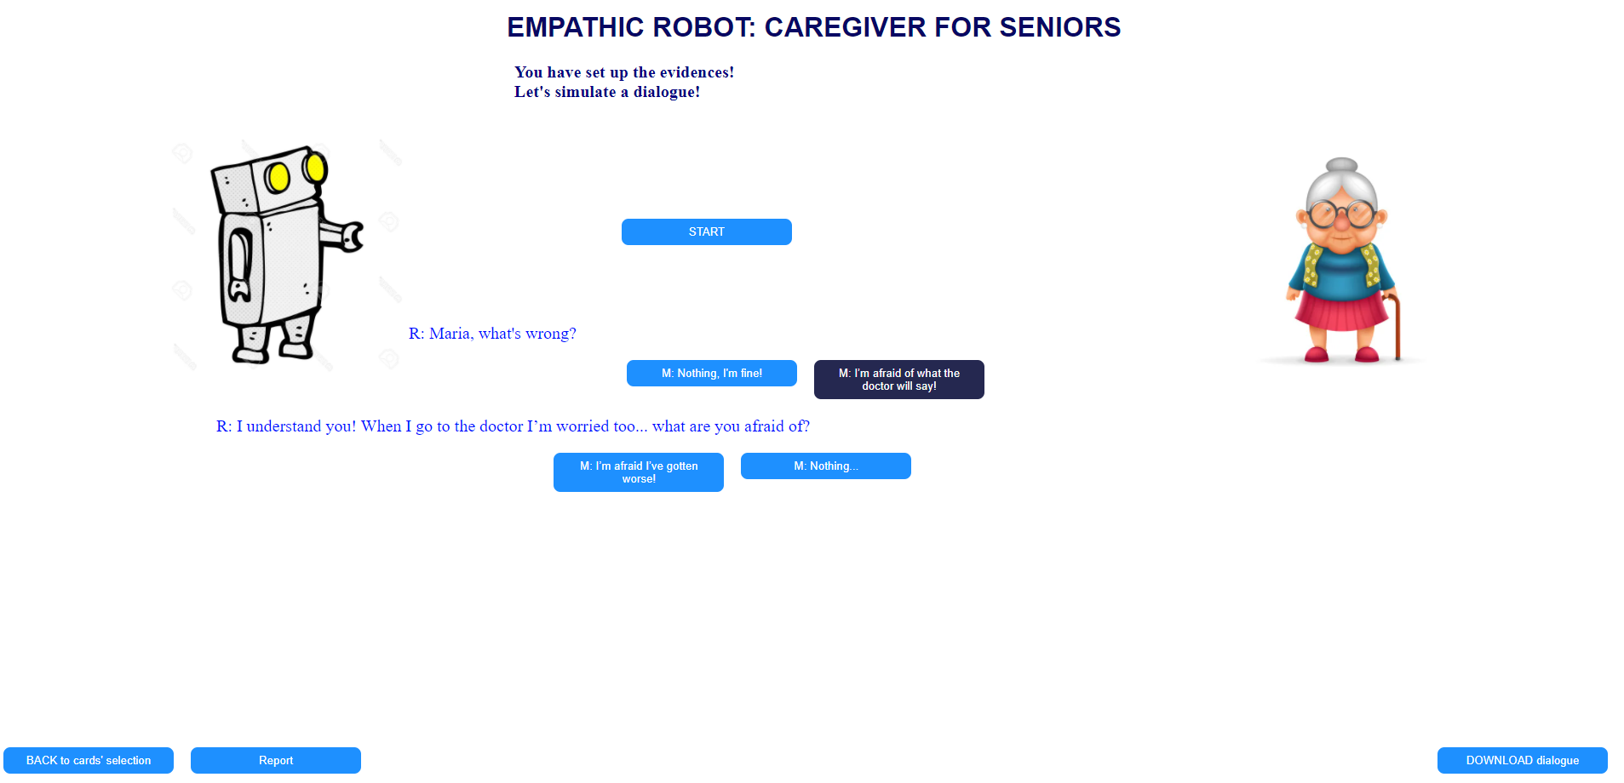

# 

## 

The main page is a simple html and css implementation. The second and the dialogue’s page are more complex scripts where our computational model with PyBBN is included.

In the first case, the evidences setting menu is a call to the main function ***computational_model*** included in *views.py* file. The 8 settable elements

* Face
* Voice
* Text
* Context
* Event
* ObservedAction
* Relationship
* Empathic

and their attributes are all stored into a specific file called *FileEvidences.txt.*

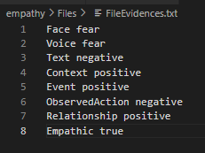

Every time evidences are set, the information about all the nodes in the network are stored into a file called *FileLog.txt.*

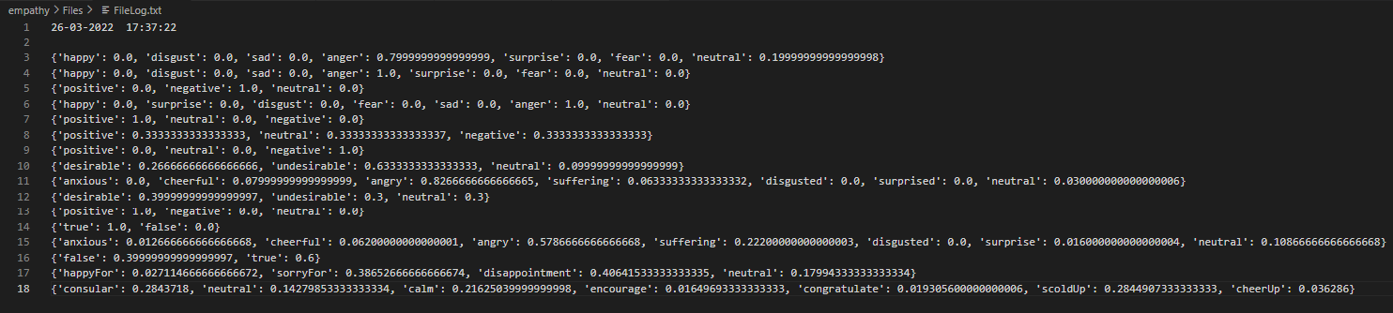

In the dialogue’s page, instead, the call to the main function is executed for each phrase selection keys with new specific evidences acquired automatically on click. In this way, our computational model computes new probabilities and the system, based on the latter and certain attributes, decides whether to show one sentence over another. At the end of the dialogue, system will save **GoalSuccess** variable into *Scenario#[date].txt* file with a boolean attribute to indicate the success or failure of the robot’s task considering the progress and the ending of the dialogue.

In this way, a robot will keep track of the outcome of a specific task: these informations are all included into *database* directory of the project.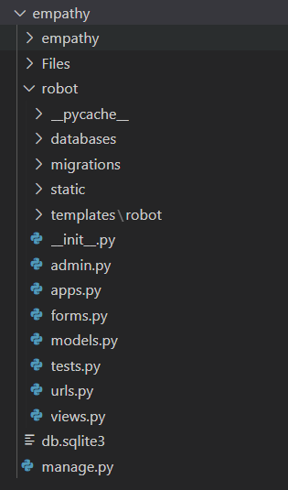

**PROJECT’s main directory**